AMERICAN TOAD
Anaxyrus (Bufo) americanus

Anaxyrus is derived from Greek meaning “A king or chief” and americanus refers to the fact that these toads have a very large distribution and range across America.

IDENTIFICATION
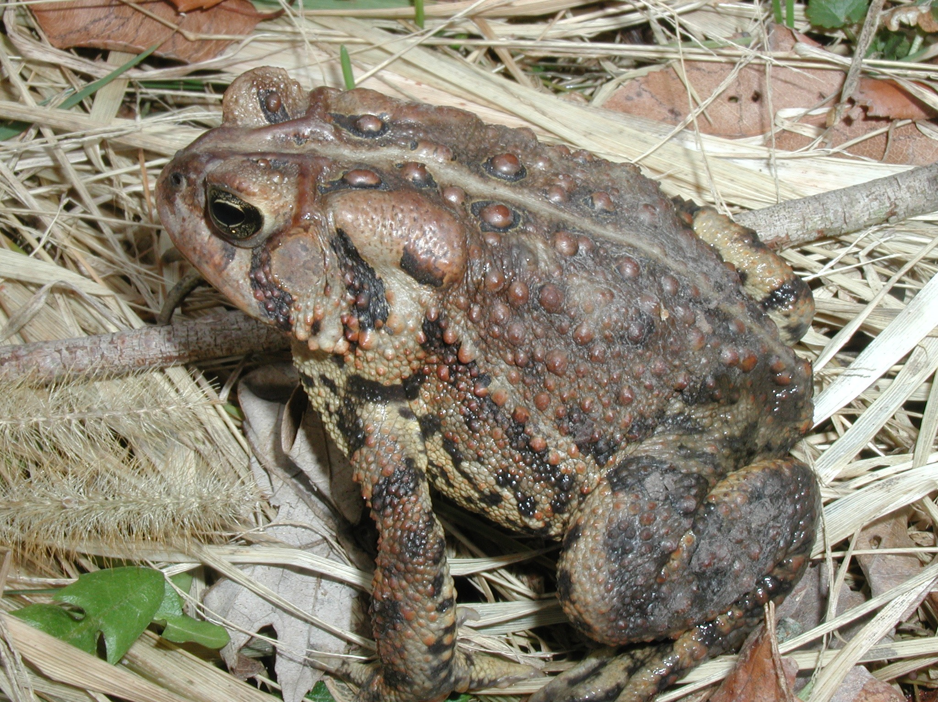
Gregory J. Lipps
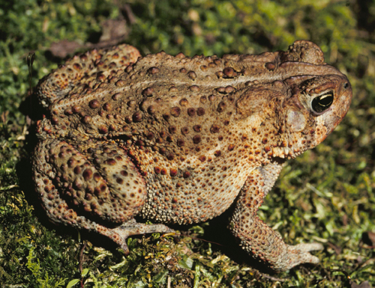
Alan Resetar

Appearance: American Toads are short, stocky toads that are variable in color; ranging between shades of brown (light to dark), sometimes with a reddish tinge, to nearly gray, or even olive. They also change their color intensity (i.e., lighten or darken) depending on their environment. The skin appears dry and warty, and in this species, dark spots on the back encircle only one or two warty bumps. Some specimens have a light colored line that runs down the back. The noticeable lumps that exist on the head behind the eyes are parotoid glands (upper right image) that secrete a foul chemical to fend off predators. Additionally, American Toads possess enlarged warts on the tibias or shins of the hind legs (lower right image).

In the Midwest, adults grow to around 2 to 3.5 inches in length. The sexes may be differentiated by comparing overall size (males are typically smaller than females) and by examining the thumbs of the front feet (in males they are dark in coloration and enlarged). The presence of a gray-colored flap of skin on the throat (the vocal sac) also helps to identify the male of this species. The tadpoles of the American Toad are small and black, with a rounded tail.

Subspecies: The Dwarf American Toad is smaller (less than about 6 cm) than the Eastern American Toad, and tends to be reddish in coloration. The spots on the back of a Dwarf American Toad, if there are any, are small and surround only one warty bump. The pale underside of the Dwarf American Toad is also less likely to be marked with spots of dark pigment than that of the Eastern American Toad.

Voice: The call of the American Toad is a melodic, fast and high-pitched trill that may last longer than 30 seconds.

Confusing species: The dark spots on the back of the Fowler’s Toad encircle three or more warts, and the parotoid glands touch the ridges behind the eyes. Warts on the hind legs of Fowler’s Toads are uniform in size, and are not enlarged on the tibias, as they may be on the American Toad.

DISTRIBUTION AND STATUS

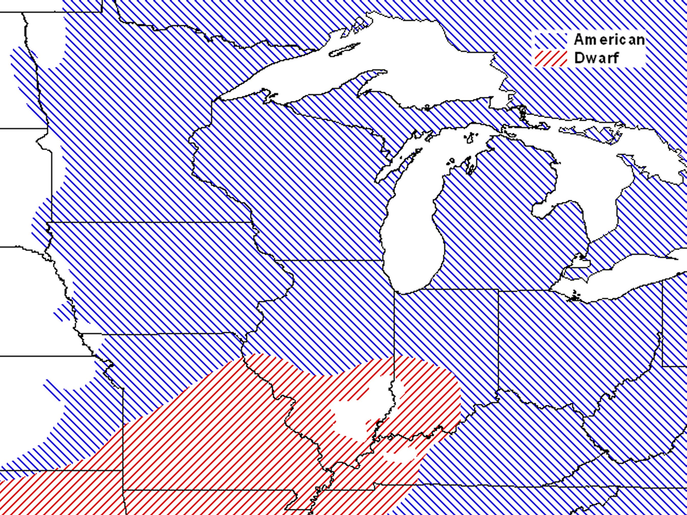The American Toad is found from the Maritime Provinces in Canada, south to Georgia and Alabama and west through northeast Texas and up into eastern Manitoba. In the Midwest, the Eastern American Toad occupies most of the range (blue), while the Dwarf American Toad (red) enters the areas from the southwest. Loss and degradation of breeding habitat may result in local population declines. However, the American Toad generally survives quite well in the Midwestern portion of its range and we consider it to be generally common.

ECOLOGY AND BEHAVIOR
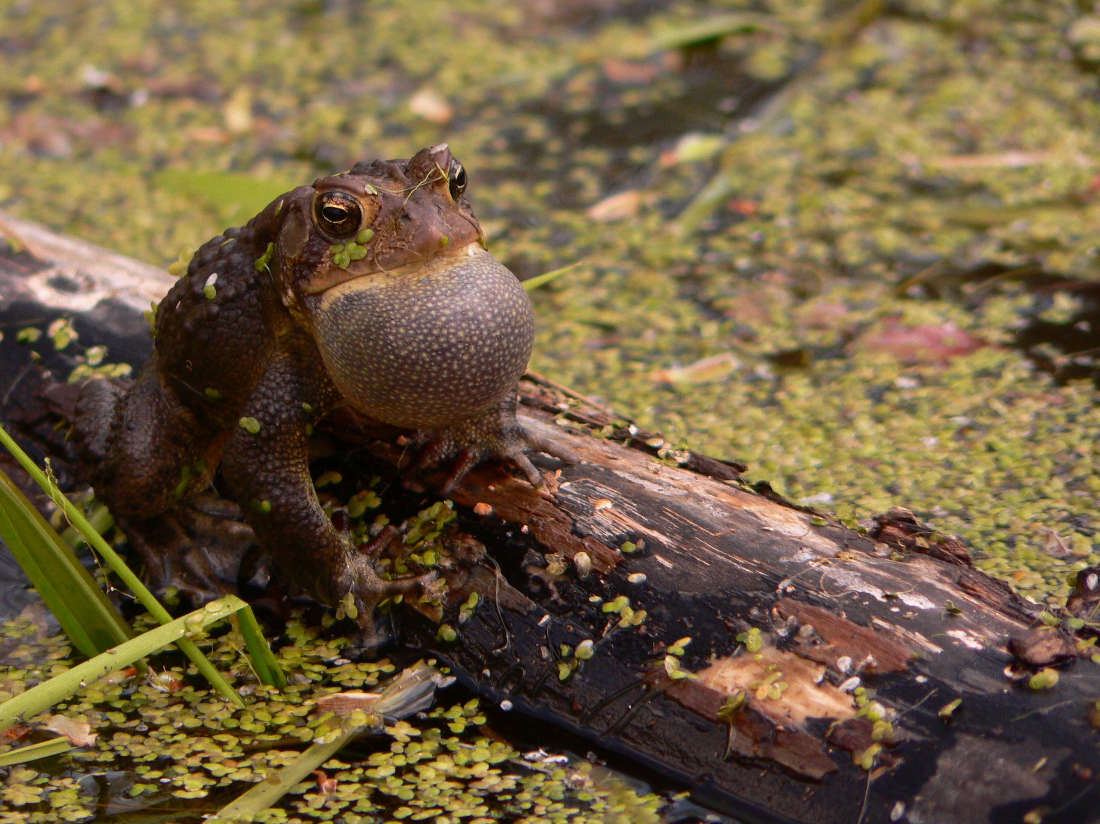
Omar Attum

Except for the breeding season, American Toads are primarily terrestrial. They use a wide variety of habitats and can be found in environments ranging from woodlands to prairies, and can even be found in backyards and agricultural areas. The primary requirements for their presence seem to be vegetative cover and a semi-permanent body of water nearby for breeding. American Toads spend much of their time hiding in leaf litter or under cover objects like rocks or logs. Breeding occurs in shallow, temporary pools in spring. Tadpoles may develop into adulthood within 30 to 40 days. They are most active in the nighttime hours and may be seen grouping near lights to consume the insects that flock there. Prey consists of a variety of insects and other invertebrates and seems to vary with whatever is widely available. During the winter months American toads hibernate underground or in other suitable sites.

