Accessing Watermark’s Student Learning & Licensure
This file contains information for accessing Purdue Fort Wayne’s assessment management system: Watermark’s Student Learning & Licensure (SLL). We refer to this as “Watermark.” Videos demonstrating how to log in are also available at the end of the file. This file contains information about:
- How to log in
- What you will see
- Finding Key Assessments in Watermark
How to login
- Use link: Watermark Login or url https://login.watermarkinsights.com/connect/purdueuniversityfortwayne
  - This link takes you to the site license access point for Purdue Fort Wayne.
  - Do NOT use Watermark’s main website. That link assumes personal accounts.
- Enter your Purdue Fort Wayne credentials.
  - Technically, this uses your Purdue West Lafayette credentials. In theory, all Purdue Fort Wayne and Purdue West Lafayette credentials are automatically synced at this point.
  - If you have trouble, contact Purdue West Lafayette’s IT Helpdesk at 765-494-4000, and ask them to reset your password. That should solve the problem.
  - If you still have trouble, contact Michael Flory at Purdue Fort Wayne at mflory@pfw.edu or 260-481-0437.
What you will see
- Most people will directly see their homepage within Watermark that reads “In Progress.”
- There will be tabs down the left side of the window. Select “In Progress” if you are not already there.
- The screen will show ALL courses you are currently taking/teaching (whether there is a Key Assessment or not).
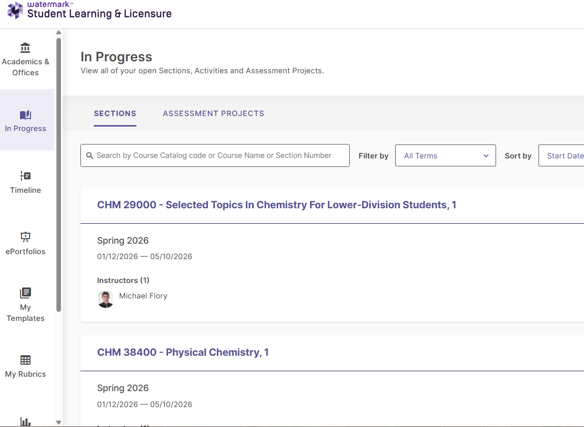
Note: Some people may get a different landing page with multiple products within Watermark. In that case, select Student Learning & Licensure.
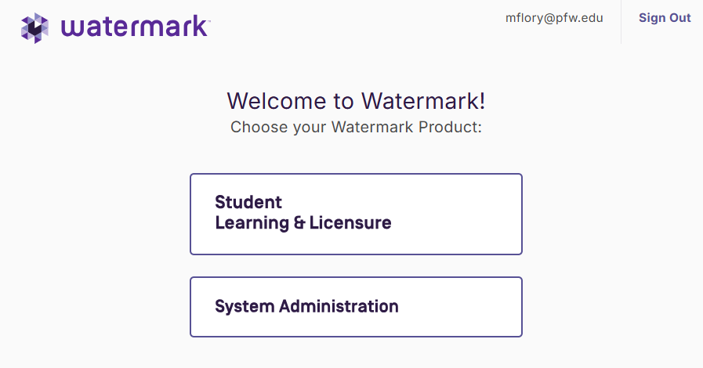
Finding Key Assessments
There are two ways to access your Key Assessments within Watermark.
- Click directly on the name of the course that has the Key Assessment. This will take you to a screen for the course, where all relevant Key Assessments are listed.
OR
- Below each course, there may be a shortcut to each Key Assessment for the course.
  - The shortcut will not be available if there are no actions to take (such as, if you have already submitted the assignment).
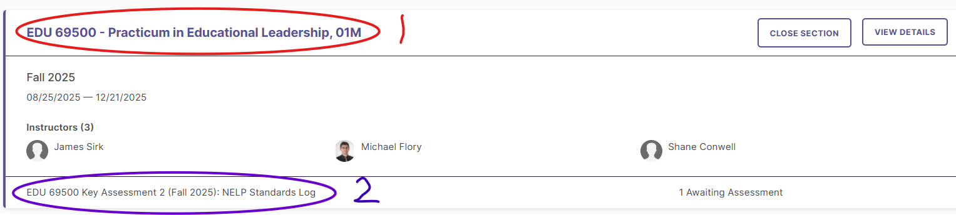
- The Key Assessment page will allow you to upload files.
- You can Save to return to your work later.
- You MUST click Submit to turn in your work.
Videos
- Student Login Video
- Faculty Login Video
For any additional help, please contact Michael Flory, Director of Assessment and Analytics, Purdue Fort Wayne School of Education at mflory@pfw.edu or 260-481-0437.

