PURDUE UNIVERSITY FORT WAYNE
World Language Education Student Teaching Observation Form

Student: Visitation Date/Time:
University Supervisor/Cooperating Teacher:

School:
No. of Students:
Subject:

Specific Observations: What did you see and hear? | Questions/comments/ connections to standards:

Observer’s additional feedback (highlight the areas of strength):

Future goals – determined jointly (based on ACTFL standards on following pages)

University Supervisor/Cooperating Teacher:

(Signature) (Date)

Student Teacher:

(Signature) (Date)

Standards and Elements

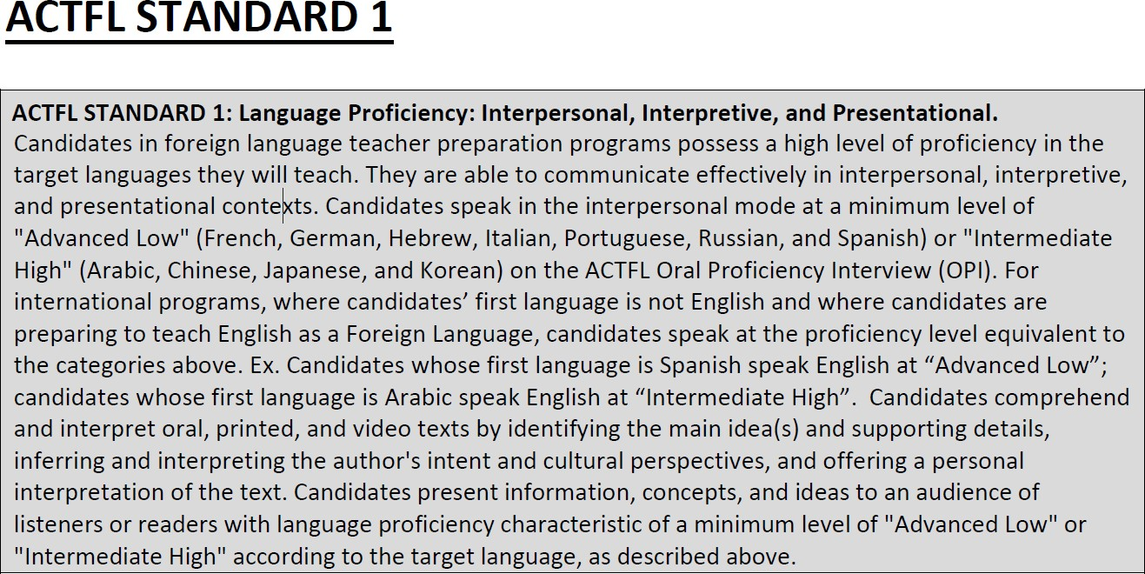

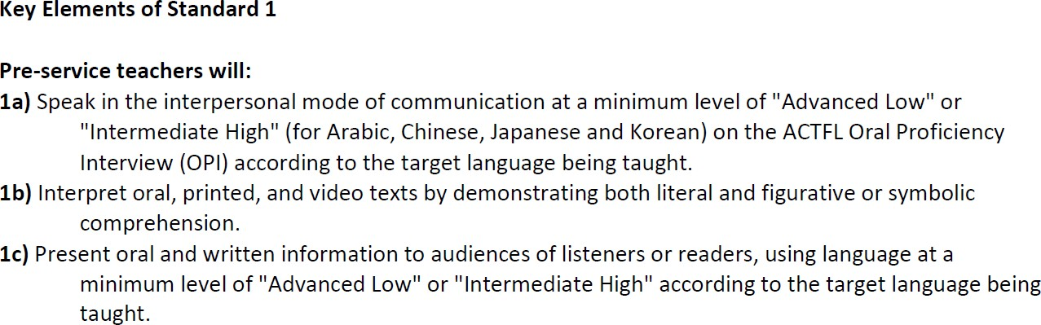

ACTFL STANDARD 2: Cultures, Linguistics, Literatures, and Concepts from Other Disciplines Candidates demonstrate understanding of the multiple content areas that comprise the field of foreign language studies. They demonstrate understanding of the interrelatedness of perspectives, products, and practices in the target cultures. Candidates know the linguistic elements of the target language system, and they recognize the changing nature of language. Candidates identify distinctive
viewpoints in the literary texts, films, art works, and documents from a range of disciplines accessible to them only through the target language.

Key Elements of Standard 2

Pre-service teachers will:
2a) Demonstrate target cuIt ur a I understandings and compare cultures th rough perspectives, products, and practices of those cultures.
2b) Demonstrate understanding of linguistics and the changing nature of language, and compare language systems.
2c) Demonstrate understanding of texts on literary and cultural themes as well as interdisciplinary topics.

ACTFL STANDARD 3

ACTFL STANDARD 3: Language Acquisition Theories and Knowledge of Students and Their Needs
Candidates demonstrate an understanding of the principles of language acquisition and use this knowledge to create linguistically and culturally rich learning environments. Candidates demonstrate an understanding of child and adolescent development, the context of instruction, and their students' backgrounds, skills, and learning profiles in order to create a supportive learning environment that meets individual students' needs.

Key Elements of Standard 3

Pre-service teachers will:
3a) Demonstrate an understanding of key principles of language acquisition and create linguistically and culturally rich learning environments. 3b) Demonstrate an understanding of child and adolescent development to create a supportive learning environment for each student.

ACTH STANDARD 4: Integration of Standards in Planning and Instruction.
Candidates in foreign language teacher preparation programs understand and use the national Standards for Foreign Language Learning in the 2.lst Century {2006) or their recently refreshed version World-Readiness Standards for Learning Languages (2015) and thei1r state standards to make instructional dedsions. Candi1dates demonstrate an understanding of the standards and integrate them into their curricular planning. They design instructional practices and classroom experiences that address these standards. Candidates use the principles embedded in the standards to select and integrate authentic materials and technology, as well as to adapt and create materials, to support
communication in their classrooms.

Key Elements of Standard 4

Pre-service teachers will:
4a) Demonstrate an understanding of the Standards for Foreign Language Learning in the 21st Century or their recently refreshed version World-Readiness Standards for Learning Languages (2015) and their state standards and use them as the basis for instructional planning.
4b) Integrate the goal areas of the Standards for Foreign Language Learning in the 21st Century
or their recently refreshed version World-Readiness Standards for Learning Languages (2015)
and their state standards in their classroom practice.
4c) Use the Standards for Foreign Language Learning in the 21st Century or their recently refreshed version World-Readiness Standards for Learning Languages (2015) and their state standards to select and integrate authentic texts, use technology, and adapt and create instructional materials for use in communication.

ACTFL STANDARD 5
ACTFL STANDARD 5: Assessment of Languages and Cultures- Impact on Student Learning. Candidates in foreign language teacher preparation programs design ongoing assessments using a variety of assessment models to show evidence of P-12 students' ability to communicate in the instructed language in interpretive, interpersonal, and presentational modes; and to express
understanding of cultural and Iiterary products, practices, and perspectives of the instructed language. Candidates reflect on results of assessments, adjust instruction, and communicate results to stakeholders.

Key elements of Standard 5

Pre-service teachers will:
Sa) Design and use ongoing authentic performance assessments using a variety of assessment models for all learners, including diverse students.
Sb) Reflect on and analyze the results of student assessments, adjust instruction accordingly, and use data to inform and strengthen subsequent instruction.
Sc} Interpret and report the results of student performances to all stakeholders in the community, with particular emphasis on building student responsibility for their own learning.

