PURDUE UNIVERSITY FORT WAYNE
Social Studies Education Student Teaching Observation Form

Student: Visitation Date/Time:
University Supervisor/Cooperating Teacher:

School:
No. of Students:
Subject:

Specific Observations: What did you see and hear? | Questions/comments/ connections to standards:

Observer’s additional feedback (highlight the areas of strength):

Future goals – determined jointly (based on NCSS standards, see next pages)

University Supervisor/Cooperating Teacher:

(Signature) (Date)

Student Teacher:

(Signature) (Date)

Standard 1: Content Knowledge
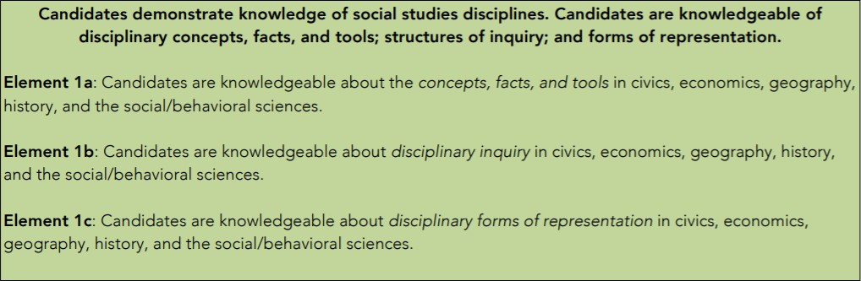

Standard 2: Application of Content through Planning
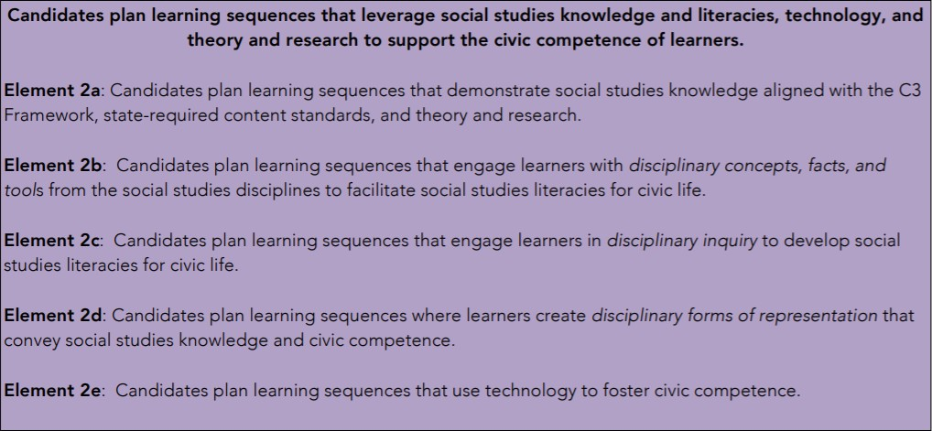

Standard 3: Design and Implementation of Instruction and Assessment

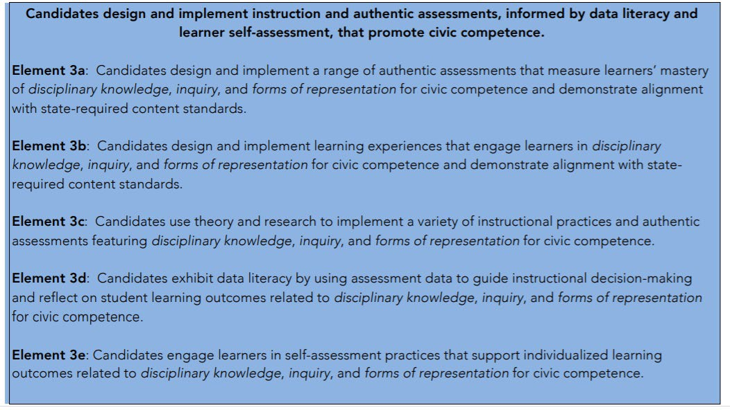

Standard 4: Social Studies Learners and Learning
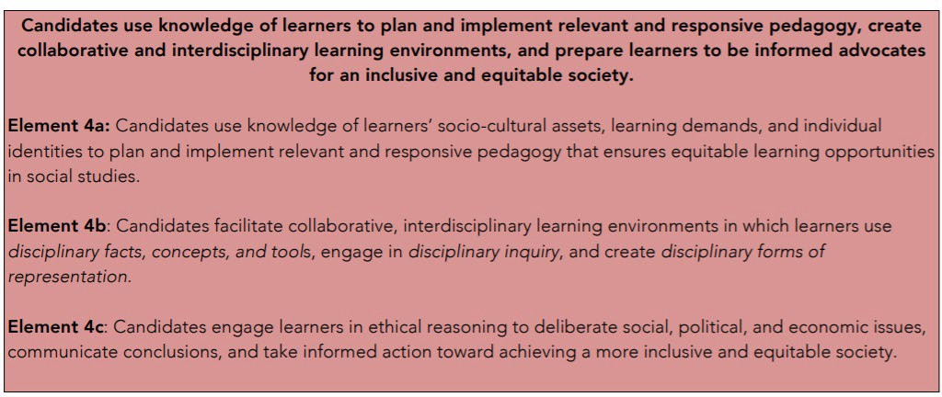
Standard 5: Professional Responsibility and Informed Action
