PURDUE UNIVERSITY FORT WAYNE
Elementary Education Student Teaching Observation Form

Practicum Student: Visitation Date/Time:
University Supervisor/Cooperating Teacher:

School:
No. of Students:
Grade:

Specific Observations: What did you see and hear? | Questions/comments/ connections to standards:

Observer’s additional feedback (highlight the areas of strength):

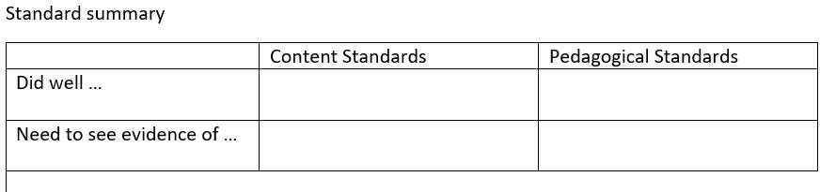

Future goals – determined jointly (based on IN REPA standards on following pages)

University Supervisor/Cooperating Teacher:

(Signature) (Date)

Student Teacher:

(Signature) (Date)

CONTENT

Elementary Education Generalist
Educator Standards

Standard 1: Foundations of Scientifically Based Reading Instruction
Elementary teachers have a broad and comprehensive understanding of foundations of reading development and effective reading instruction grounded in scientifically based reading research (SBRR).

Standard 2: Components of Scientifically Based Reading Instruction
Elementary teachers have a broad and comprehensive understanding of the major components of reading development and demonstrate the ability to provide assessment, instruction, intervention, extension, and ongoing progress monitoring in reading.

Standard 3: English Language Arts

Elementary teachers have a broad and comprehensive understanding of fundamental concepts and processes of English language arts and demonstrate the ability to provide content-specific instruction in English language arts.

Standard 4: Mathematics
Elementary teachers have a broad and comprehensive understanding of fundamental computation skills and concepts and processes of mathematics and demonstrate the ability to provide content-specific instruction in mathematics.

Standard 5: Science
Elementary teachers have a broad and comprehensive understanding of fundamental concepts and processes of the science and engineering disciplines and demonstrate the ability to provide content-specific instruction in science.

Standard 6: Social Studies
Elementary teachers have a broad and comprehensive understanding of fundamental concepts and processes of social studies and demonstrate the ability to provide content-specific instruction in social studies.

Standard 7: Fine Arts
Elementary teachers have a broad and comprehensive understanding of fundamental concepts and processes of the fine arts and demonstrate the ability to provide content-specific instruction in the fine arts.

Standard 8: Health, Wellness, and Physical Education
Elementary teachers have a broad and comprehensive understanding of fundamental concepts and processes of health, wellness, and physical education and demonstrate the ability to provide content-specific instruction in health, wellness, and physical education.

1

PEDAGOGY
School Setting Developmental Standards–Elementary Education
Educator Standards

Standard 1: Student Development and Diversity
Elementary education teachers have a broad and comprehensive understanding of student development and diversity and demonstrate the ability to provide instruction that is responsive to student differences and that promotes development and learning for all students.

Standard 2: Learning Processes
Elementary education teachers have a broad and comprehensive understanding of learning processes and demonstrate the ability to facilitate student achievement.

Standard 3: Instructional Planning and Delivery
Elementary education teachers have a broad and comprehensive understanding of instructional planning and delivery and demonstrate the ability to plan and deliver standards-based, data-driven differentiated instruction that engages students, makes effective use of contemporary tools and technologies, and helps all students achieve learning goals.

Standard 4: Assessment
Elementary education teachers have a broad and comprehensive understanding of assessment principles and practices and demonstrate the ability to use assessment to monitor student progress and to use data to guide instructional decision making.

Standard 5: Learning Environment
Elementary education teachers have a broad and comprehensive understanding of student learning environments and demonstrate the ability to establish positive, productive, well-managed, and safe learning environments for all students.

Standard 6: The Professional Environment
Elementary education teachers have a broad and comprehensive understanding of professional environments and expectations and demonstrate the ability to collaborate with others to improve student learning, to engage in continuous professional growth and self-reflection, and to adhere to legal and ethical requirements of the profession.

1

