Senior Capstone Project Proposal
The project is designed for a team of students working toward completion of a project, within two semesters¹.

Title | Software, PLC programming, and hardware to provide automated water meter readings to HMI on water meter test stand
Sponsor | Contact person: Andrew Bain  Company name: The Ford Meter Box Company, Inc.  Contact info: abain@fordmeterbox.com (260) 569-3535
Type | Application development | Information systems | Research-focused
Description | Water Loss for a water utility can result in millions of dollars of lost revenue for water utilities. Several industry and State groups are working to improve water loss throughout the US. One are of focus areas of Water Loss programs is testing the accuracy of the water meters registering the volume to homes and businesses. Ford Meter Box has been supplying water meter test stands since 1916 and is the industry leader in water meter testing equipment. Current water meter testing technology requires manual data entry for calculations of volume and accuracy of the water meters even with the most automated test systems.  Automated meter reading technology has existed for utilities recording water consumption but the challenge with a meter testing application is that each meter brand requires a specific software to utilize the AMR technology of that meter. Ford Meter Box would like to create a vision system capable of being brand agnostic and providing a way that the meter test stand can eliminate the possibility of incorrect data entry for the accuracy test. More so, water meter technology has evolved from an odometer style reading or a dial style reading to an electronic display. Further challenging the issue is that there is not a standardized gradation for the meter reading. Some water meters measure down to the thousandth of a gallon while others measure every 1 gallons. This wide variety of meter registers complicates the issue and would require significant programming to account for all possible technologies.  Hobbyists, utilizing raspberry pi-type equipment, have begun to create automated meter reading technology.

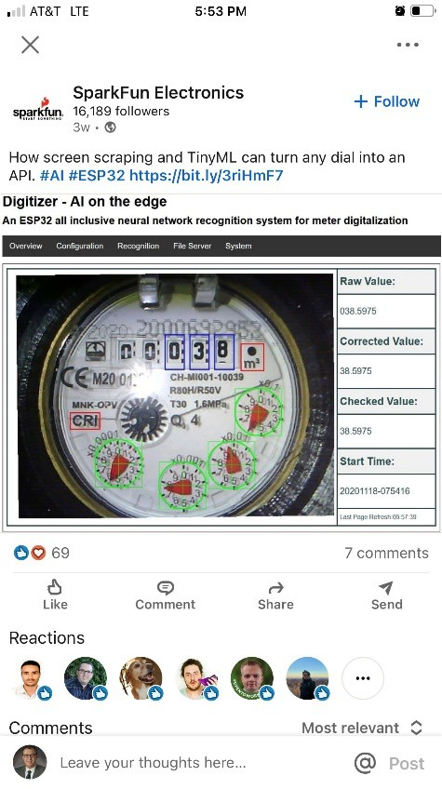
Team members would be expected to research and perform literature review on possible equipment needed. Based on recommendations for equipment, Ford Meter Box would supply or acquire the recommended hardware to build the solution.
Deliverables would include a meter reading device, programmed to read current possible meter types and then transfer the data into an existing meter testing program. This project brings value to water utilities by eliminating the data entry errors and improving the overall quality of their meter testing programs.
Team size | 2 | 3 | 4 | > 4
Required backgrounds | No formal expertise needed.
Required resources (HW/SW) | Ford Meter Box Company will provide or acquire.
Additional requirements | Team will need to be onsite at Ford Meter Box Company Inc. in Wabash for at a minimum 50% of the project time. The direct interaction with the test stand, the test stand engineering team, and various meter types will be necessary ensure success.

Other notes | Basic considerations for aesthetic and functional design of device will be needed.
Students | 5 ECE Students
Faculty Advisor | Dr. Yanfei Liu

