




G R A D U A T E S T U D I E S

MA ST E R O F SC IE N C E IN E N G IN E E R IN G
C O N C E N T R A T IO N IN SY ST E MS E N G IN E E R IN G

P F W . E D U /G R A D U A T E


A MESSAGE FROM THE DIRECTOR
David S. Cochran, Ph.D.
Professor of Systems Engineering Director of the Center of Excellence in Systems Engineering Systems Engineering Graduate Program Director
cochrand@pfw.edu

Thank you for considering a Master of Science in Engineering with a concentration in Systems Engineering from Purdue University Fort Wayne. You will be working directly with former MIT Professor Dr. David S. Cochran, who is a world-renowned scholar in the field of System Design and Systems Engineering. Dr. Cochran is a two-time winner of the prestigious Shingo Research Prize for Excellence in Manufacturing for his work in the design of sustainable enterprise systems. The PFW Systems Engineering concentration is designed to provide you with the skills and mindset to facilitate the practice of system design to lead change in your organization. The course projects in the program provide you with the skills to resolve real-world issues to address your business growth challenges. You will learn how to make the best use of the resources that you are entrusted with to meet internal and external customer needs within your enterprise.



BENEFITS
SHARPEN YOUR SKILLS AND ACHIEVE YOUR GOALS
The Master of Science in Engineering (MSE) with a concentration in Systems Engineering equips you with system design thinking that can help you become a:

Director of Engineering Director of Operations
Director of Quality & Continuous Improvement Operations Manager
Supply Chain Manager
Systems Engineering Professional

By practicing collective system design - Tone, Thinking, Structure, and Actions - you can grow your organization and meet the needs of your internal and external customers.
LEARN FROM DEDICATED, EXPERT FACULTY
Our faculty have expertise in a wide range of areas. Students benefit from the distinct and renowned breadth of knowledge our professors and instructors have developed throughout their careers.

Systems engineering research and engagement areas include:

Collective System Design and Leadership Enterprise Design to Become Lean Healthcare System Design and Improvement Language for System Design
Lean-Linked Cell System Design Physical Simulation and Modeling of Systems
Supply Chain Material and Information Flow Sustainable Enterprise Design
Systems Architecture

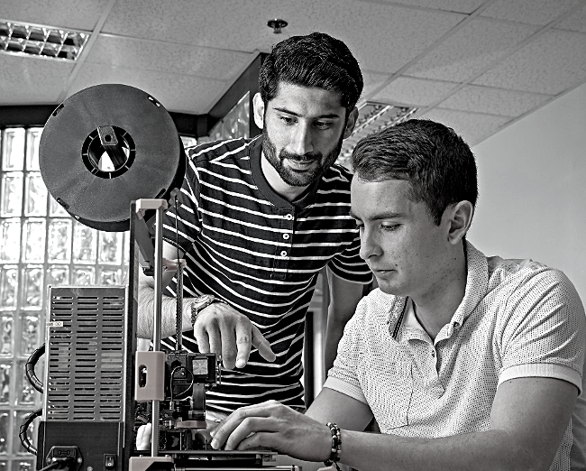
"The MSE program at Purdue University Fort Wayne, with the Systems Engineering concentration, opens for students the opportunity to explore new horizons. The tone and attitude of the faculty greatly facilitates students to learn. Interactive lessons, guest speakers, and more importantly, application of theoretical knowledge to engineering practice, makes Systems Engineering the best program for perspective graduate students. I believe that my program will help me to become a professional in the systems engineering field and encourage me to conquer new peaks."
THE PURDUE FORT WAYNE DIFFERENCE
Stand out with a graduate degree that enhances your qualifications through:

Course offerings designed for working adults
Internationally recognized degree at a fraction of the cost
Personal attention from dedicated faculty Small class sizes
Kamran Veliyev

COURSES
COURSE OF STUDY
Students are required to complete 30 credits of coursework to earn a Master of Science in Engineering degree. The Systems Engineering (SE) concentration is flexible in allowing students to tailor their program courses to their specific career goals.
Our students complete a Plan of Study during their first semester to document their intended curriculum.

CORE COURSES
Four 500-level graduate Systems Engineering core courses are required.

SYSTEMS ENGINEERING CORE REQUIREMENTS (12 CREDIT HOURS)

SE 52000 Engineering Economics
SE 53000 Systems Engineering Management SE 54000 System Architecture
SE 55000 Manufacturing System Design for Sustainability SE 58301 Engineering Statistics for Industry
In-Person, Spring - Odd Years In-Person, Fall - Odd Years
In-Person, Spring - Even Years
In-Person, Fall - Even Years and Asynchronous Online* Asynchronous Online*

* Offered second half of Fall, Summer, and Spring semesters each year.
ENGINEERING ELECTIVE COURSES

Students have the opportunity to take courses from the following departments:
ENGINEERING/ MATH/ STAT/ ACS/ CS/ TECHNOLOGY REQUIREMENT
A minimum of two graduate-level courses from engineering (ECE, ME, ENGR), mathematics (MA), statistics (STAT), computer science (ACS or CS), or engineering technology (ET) are required.**
Math (MA), Statistics (STAT) or Computer Science (CS)
Mechanical Engineering Electives

SE 58301 Engineering Statistics for Industry STAT 51400 Design of Experiments
MA 51100 Linear Algebra
CS 59000 Topics In Computer Science ACS 57700 Knowledge Discovery and Data Mining
ME 54400 Modeling and Simulation of Mechanical Engineering Systems
ME 54500 Finite Element Analysis: Advanced Theory and Applications
ME 54600 CAD/CAM Theory and Advanced Applications ME 54700 Mechatronics, Robotics, and Automation

Electrical Engineering Elective Courses
Computer Engineering Electives

ECE 54300 Wireless Communication Networks ECE 56900 Introduction to Robotics
ECE 58400 Linear Control Systems
ECE 53800 Digital Signal Processing I
ECE 54700 Introduction to Computer Communication Networks ECE 56700 FPGA Designs for Signal Processing Applications

** The above courses are some of the options students have in the program.

A non-thesis option student successfully completes two general elective graduate-level courses in consultation with their advisor. Appropriate areas for coursework include: Engineering, Physics, Math, Computer Science, Technology, Business, Organizational Leadership, etc. The purpose of these courses is to give students flexibility to tailor the program to meet their specific needs.
GENERAL GRADUATE ELECTIVES REQUIREMENT
Doermer School of Business MBA Programs Electives
Organizational Leadership

- BUS 54202 - Leadership and Management of People in Organizations
- BUS 55200 - Management Of Information Technology
- BUS 56000 - Marketing and Customer Relationship Management
- OL 51000 - Foundations of Behavior and Leadership in Organizations
- OL 53000 - System Change and Organization Development
- OL 54000 - Leading Collaborative Projects and Work Teams

A student can opt to replace six elective credits with thesis research. To take advantage of this option, the student must prepare a thesis proposal and gain departmental approval prior to signing up for thesis credits.
THESIS OPTION

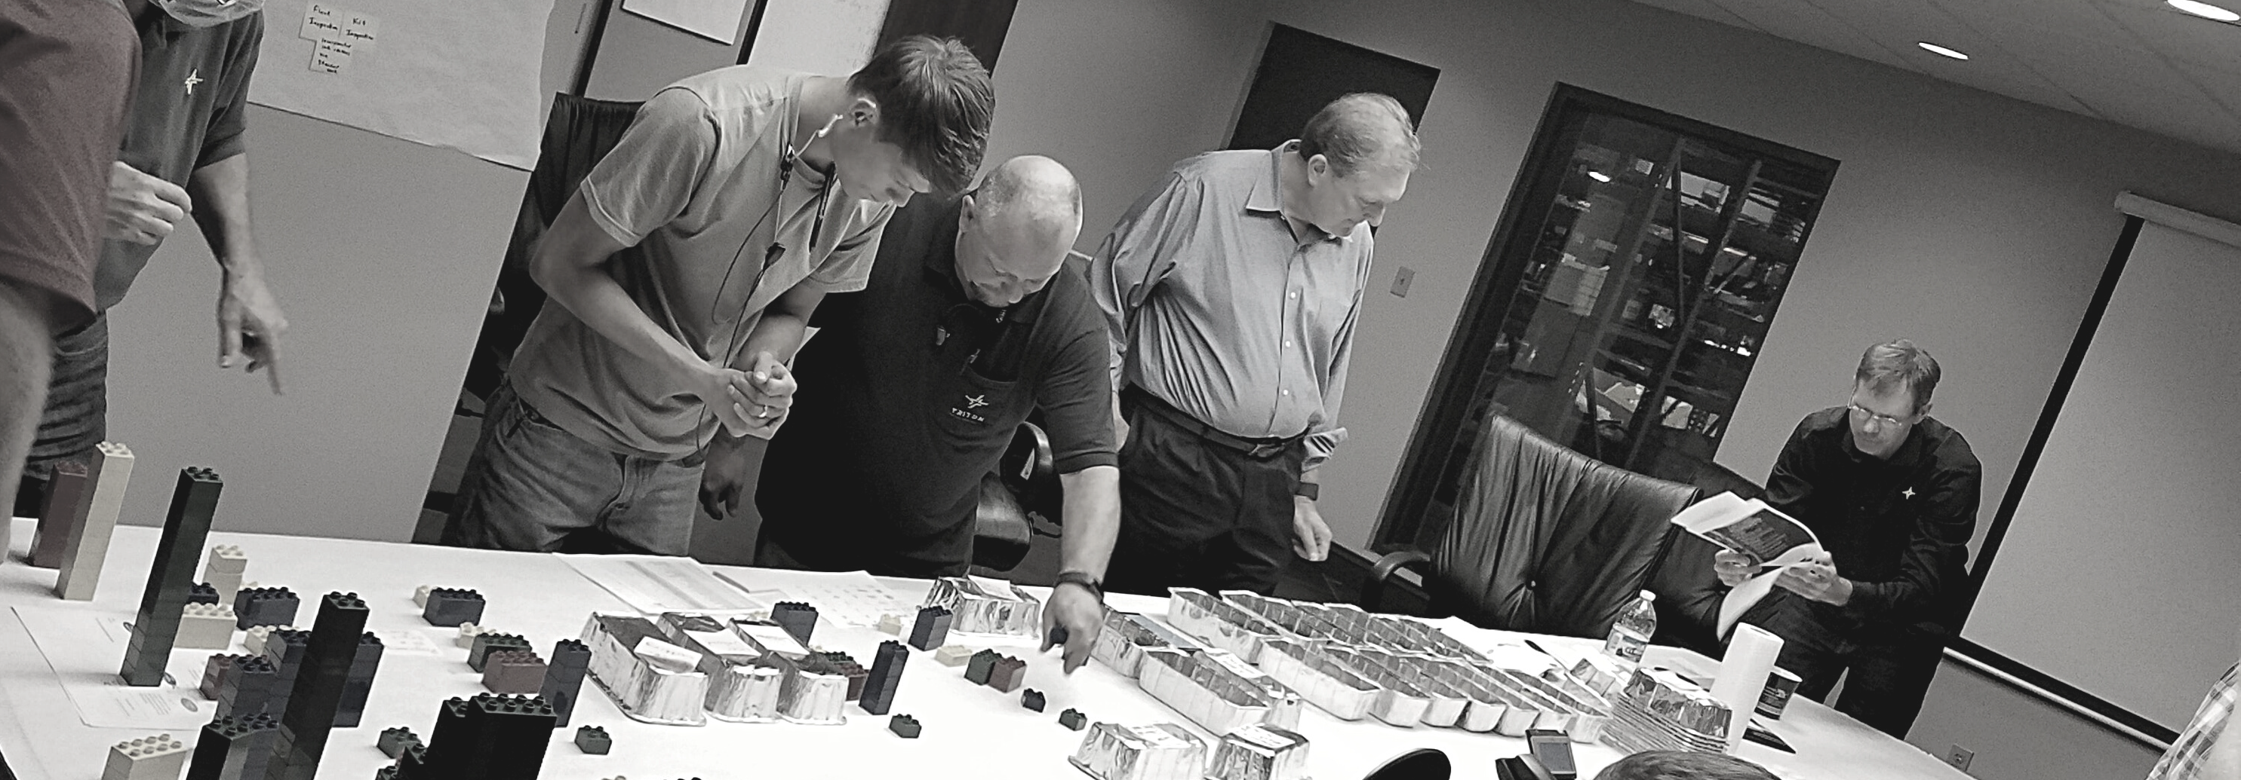
A thesis option is available for students who would like to do research in the area of Systems Engineering. Six hours of thesis research replaces the two general electives in the generic Plan of Study. Thesis research can be focused on a project sponsored by the student's employer or in conjunction with work being done by the Center of Excellence in Systems Engineering.

“Although a master’s degree was not in my original plan, my professors (and the overall environment) encouraged me to pursue an MSE degree in Systems Engineering. This
program provides the theory behind system design, but the major emphasis is on the application of this theory. Systems engineering can be applied to so many concepts and the
classes are structured to tailor the applications to your
specific interest. I believe this approach allows me to best adapt my education to my career goals in addition to
making the learning environment enjoyable.”

Joseph Smith
"Systems Engineering has taught me how to unlock the value of people (organization’s human capital and customer
relationship capital) to maximize the return on tangible assets (technology, product, structural capital). I have learned to see the hidden waste in organizations working in Silos. Thanks to Prof. Cochran, who mentored me on how to define customer-supplier connections throughout the organization for
achieving system goals, I learned how to exchange my
knowledge, energy, wisdom, and viewpoints with the people in my organization, our customers, and the community at large."

Shahab Shah

PLAN OF STUDY
You can find guidelines for developing your Plan of Study here.
You can find the Graduate Program Guideline information for the MSE program here.

CERTIFICATE IN SYSTEMS ENGINEERING (12 CREDIT HOURS)
The Certificate in Systems Engineering is designed to recognize students who have completed any four courses in systems engineering. Any engineering or non engineering student with an undergraduate bachelor's degree can apply for the Systems Engineering Certificate. In addition, the courses taken for the Systems Engineering Certificate will be counted towards the MSE degree with Systems Engineering concentration. The curriculum provides students with a background in systems engineering fundamentals, system architecture, economics, and engineering management that can be applied to any industry including manufacturing, healthcare, or education. The systems engineering body of knowledge prescribes techniques and “best practices” for developing complex or interdisciplinary products. Professional engineers will find the SE program beneficial in helping them understand modern product development principles and best practices.

SYSTEMS ENGINEERING CERTIFICATE REQUIREMENTS
The Systems Engineering Certificate will require satisfactory completion of 12 credit hours of course work
(B or better) in the specified engineering courses. No course with a grade below a “B” may be applied toward the certificate.

Choose any four of the following Systems Engineering course options: SE 52000 Engineering Economics (3 cr.)
SE 53000 Systems Engineering Management (3 cr.) SE 54000 System Architecture (3 cr.)
SE 55000 Manufacturing System Design for Sustainability (3 cr.) SE 58301 Engineering Statistics for Industry (3 cr.)

VALUE OF THE SYSTEMS ENGINEERING CERTIFICATE
Systems engineering is a structured approach to developing technical solutions that satisfy customer needs. Unlike traditional forms of engineering, systems engineering focuses on processes used to design, develop, verify, and validate new products and systems. The Systems Engineering Certificate addresses the needs of professional engineers that already possess a master’s degree or do not have the time or financial resources to commit to an MSE program.
HOW TO APPLY
To apply for the Certificate in Systems Engineering follow the application instructions outlined on the APPLY page. Admission to the certificate program requires that students meet the requirements of the Purdue University Graduate School. Candidates to the certificate program are expected to have earned a bachelor’s degree in an engineering discipline.

DEGREE APPLICATION

DEADLINES

MAY
1
JUN
30
NOV
1
NOV
15

International: regular fall admission
U.S. Citizen: regular fall admission
International: regular spring admission
U.S. Citizen: regular spring admission

STEPS TO APPLY FOR MSE DEGREE
SYSTEMS ENGINEERING CONCENTRATION
To begin your application, click here and create an application.

Select Campus - Purdue Fort Wayne
Select Proposed Graduate Major - Engineering For Area of Interest, select - Systems Engineering
For Degree Objective select - MS in Engineering (MSE) Continue on with application

OFFICIAL TRANSCRIPTS

You must provide official transcripts and/or academic records at the request of the graduate program or if you are admitted and choose to enroll. An official transcript bears the original signature of the registrar and/or the original seal of the issuing institution. An unofficial transcript printed from your current/previous institution(s) student system is not an acceptable document. Official documents should be submitted to:
Purdue University Fort Wayne Office of Graduate Studies 2101 E Coliseum Blvd., KT 140 Fort Wayne, IN 46805

Domestic transcripts must be mailed directly from a Registrar’s office to the Office of Graduate Admissions. (You can choose to send the transcripts yourself, but the transcripts must be in an envelope sealed by the Registrar).

INFORMATION

INTERNATIONAL APPLICANTS
All international applicants must also submit the following items to be considered for admission:

- English Proficiency Scores:
TOEFL for Non-Native English Speakers
Minimum Paper-Delivered Test - no overall score reported with the following minimum section requirements: Reading: 19
Writing: 18
Listening: 14
Minimum Internet-Based Test (IBT) Overall Score: 80 with the following minimum section requirements: Reading: 19
Speaking: 18
Listening: 14
Writing: 18

IELTS (Academic Module): An alternative to the TOEFL, overall band score of 6.5 or higher with minimum section requirements:
Reading: 6.5
Listening: 6.0
Speaking: 6.0
Writing: 5.5

ELS - Certificate Level 112

Routine waivers of an English Proficiency exam are granted for applicants who have been conferred a baccalaureate or graduate or professional degree within the last 24 months from an institution where English is the primary language of instruction in a country/location where English is the native language.

- Transcript Evaluation
International Applicants must submit original and certified copies for every institution of higher education attended. All documents must be submitted in both English and in the original language. All candidates must hold a four-year undergraduate degree or equivalent in any discipline from a recognized institution.

- Proof of Financial Support
An official letter and financial statement from a bank, company, or government sponsor indicating the availability of sufficient funds to pay for your tuition and living expenses is required.

- Visa and/or Permanent Resident Card (PRC)

INTERNATIONAL TRANSCRIPTS SHOULD BE MAILED DIRECTLY TO THE OFFICE OF INTERNATIONAL EDUCATION

Purdue University Fort Wayne
International Education
2101 E. Coliseum Blvd, Walb Union 145 Fort Wayne, IN 46805-1499, USA Phone: +1-260-481-6034
Email: intladmissions@pfw.edu

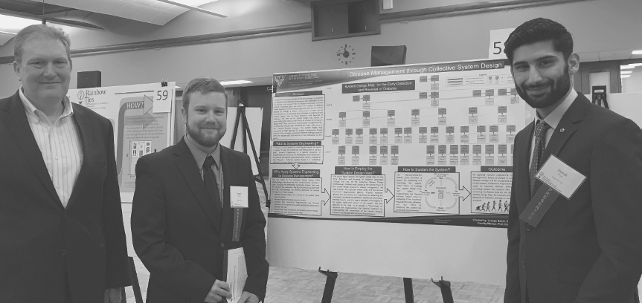


P F W . E D U / G R A D - IN F O 2 60- 4 81 - 61 1 1
E A / E O U

