TITLE OF THESIS
by
Your Name

A Choose Thesis Type
Submitted to the Faculty of Purdue University
In Partial Fulfillment of the Requirements for the degree of

Choose Degree

Choose Department
Choose Campus Location, Indiana
Choose Graduation Term

THE PURDUE UNIVERSITY GRADUATE SCHOOL
STATEMENT OF COMMITTEE APPROVAL
Dr. John Doe, Chair
School of Aeronautics and Astronautics
Dr. Jane Doe
School of Aeronautics and Astronautics
Dr. Jim Doe
School of Aeronautics and Astronautics
Add or Delete Committee Member
Add or Delete Department
Add or Delete Committee Member
Add or Delete Department

Approved by:
Dr. FORM 9 THESIS FORM HEAD NAME HERE

Dedicated to your custom dedication

ACKNOWLEDGMENTS
Type your acknowledgements here. The acknowledgements section is typically reserved for professional dedications. You may also add funder information here or any other copyright acknowledgements that may be required of journals whose articles are you are re-using in this thesis.
TABLE OF CONTENTS
LIST OF TABLES 6
LIST OF FIGURES 7
EXTRA HEADINGS 8
ABSTRACT 9
1. THESIS FORMATTING GUIDE 10
1.1 Thesis types 10
1.2 Margins 11
1.3 Heading Styles 11
1.3.1 Heading style placement 12
1.4 Generating a Table of Contents 12
1.5 Figures and Tables 13
1.5.1 Captions 15
1.5.2 List of Figures and Tables 18
1.6 Page Numbers 18
1.6.1 Issues with Pagination 18
1.7 Paragraph Settings 19
1.8 Block quotes 19
1.9 Embedded Videos and 3D models 19
1.10 Appendix 19
1.11 References 20
1.12 Cross-reference 20
1.13 Document Accessibility Statement 20
2. THIS BEGINS A NEW CHAPTER 21
APPENDIX A. SURVEYS 22
APPENDIX B. THIS IS A NEW APPENDIX 23
REFERENCES 24
VITA 25
PUBLICATIONS 26

LIST OF TABLES
Table 1.1. How to format a landscape page. Since this table is the only content on this page and does not take up the entire page, it is centered on the page vertically to make the format more visually appealing. 14
Table 1.2. The table depicted below fits between two paragraphs. Table captions should be single spaced and centered on the page. All table captions should have 24pt space above and 6pt space after the captions. On this particular example, I have indented the caption 0.5” from both left and right margins to have a better appearance above the table. 16
Table 1.3. This table shows what the spacing options should be between figures/tables and their captions. Add one extra space after tables to prevent text from bumping up against the table. If tables contain notes, you may leave the notes single space under the table and add one extra space below the note and before the continuation of main body text. 18

To update this list with your captions, after you have properly captioned all tables, right click on the table above and press “update field” then “update entire field” and all of your captions will appear. The goal is that the captions will appear properly formatted. If your list appears to be formatted differently, you will need to manually update the formatting to follow the example given above.

LIST OF FIGURES
Figure 1.1. The figures above depict how to format captions for figures and tables that cannot accommodate an entire figure and its caption on one page. You can see that the caption is placed on the page BEFORE the figure/table and it is the only text on the page, vertically and horizontally aligned. 13
Figure 1.2. The figure depicted above is wrapped within text and has the caption immediately below the figure. This text-wrapping method is acceptable. Caption sizes may go as low as 10pt. 15
Figure 1.3. The figure depicted above fits between two paragraphs. Notice that the figure caption is single spaced and centered on the page. All figure captions should have 6pt space before and 24pt space after the captions. 15
Figure 1.4. This figure represents depicts the amount of space that should appear between the figure caption and continuation of the text. The caption here is also indented from left and right margins to have a better appearance below the figure. 16

To update this list with your captions, after you have properly captioned all figures, right click on the table above and press “update field” then “update entire field” and all of your captions will appear. The goal is that the captions will appear properly formatted. If your list appears to be formatted differently, you will need to manually update the formatting to follow the example given above.

EXTRA HEADINGS
If you do not have a Glossary, List of Abbreviations, List of Symbols, or Nomenclature section, delete this page.

Entries should be spaced consistently. Single spacing or 1.5 line spacing is preferred. Two columns are acceptable in these sections.

ABSTRACT
An abstract is a concise summary of your thesis. A typical thesis abstract should not be longer than one page in length, though the Graduate School does not place a limit on how short or long the abstract may be. Please summarize your research and be efficient in your writing when creating your abstract.

THESIS FORMATTING GUIDE
This template is best used with MS Office 2016 on a PC or MS Word 2016 on a Mac. We suggest that you turn on the Show/Hide tool (¶) found on the Home ribbon so you can track you spacing and section breaks. Font sizes are as follows: 12 point for all text and subheadings, 14 point for all Chapter and Major headings, 10-12 point for captions. All text will have Times New Roman font, though figures and tables may have a different font style. This template is preloaded with 1.5 line spacing and is set for justified text. Justified text evenly distributes the text between margins, which gives your document a more polished look.
The Graduate School is fairly flexible with thesis formatting, but we do require use of our templates to help guide candidates in the right direction. Consistency is the key to an acceptable formatted thesis and the settings and instructions that are found throughout this template will help reduce, or even eliminate, the need for format revisions at deposit time. We encourage every candidate to schedule a format consultation at least 2 weeks prior to their thesis defense to ensure your formatting is perfect which will allow you to focus on content corrections after the defense and not need to worry about major formatting.
We recommend keeping a copy of this template to refer back to in the event you have questions. If you have questions regarding the template or formatting, feel free to contact us for help.

Thesis types
Three types of theses are accepted by the Graduate School:
- Traditional: A traditional thesis is a document that provides a complete and systematic account of your research. A typical traditional thesis has five chapters (Introduction, Literature Review, Methods, Results, Discussion and Conclusion).
- Article-Based: An article-based thesis is a collection of published (or will be published) research articles. This thesis type may include an introductory and concluding chapter, though they are not required. Theses authored using this structure will need to include acknowledgement of prior publication within the respective chapter. Although each journal may have specific statement requirements, the acknowledgment should be single spaced and appear 3 single spaces under the chapter title. Consult your publisher regarding required information that should appear in this acknowledgment.
- Creative Work: The Graduate School is prepared to accept theses in creative formats subject to departmental and committee approval. Students wishing to submit a creative work as their thesis requirement should consult with their committee chair and contact the Thesis & Dissertation Office with their proposal.
Thesis structures may vary by department. Please consult with your committee for specific departmental thesis formatting requirements.

Margins
Margin requirements are 1” left, bottom, right, and top margins. 1.5” top margins are required on Title and Statement of Approval pages.
Phdbookbinding.com recommends 1.25” left margins for their printing service. The Boiler Copy Maker for screw and post bindings recommends 1.5” left margins – if you wish to have a hard bound copy made. The Graduate School will only accept the digital copy you upload to Hammer Research Repository (HammerRR) which requires 1” left margins.

Heading Styles
There are many heading styles that have been added to the Styles Ribbon. You should use the applied styles above to any headings you have throughout your document as this will help you generate your Table of Contents automatically. If you open the navigation toolbar [Ctrl + F] and under the search document bar you choose “Headings” you will be able to easily track which headings will go in your table of contents. All chapter titles need to be typed in ALL CAPS and will also need to appear that way in the Table of Contents. All styles have built in spacing, so no extra spaces are needed above or below a heading.
If after you apply a Style to a heading and you receive Error! Bookmark not defined in your Table of Contents after updating the page number, go back to your heading that is causing the issue and make sure there is still a style applied to it. You can update the entire table to resolve the issue – if you had previously formatted the Table of Contents, you may have to re-format.

Heading style placement
If you prefer that your headings appear differently than what was been built into the template, you may adjust them to fit the style that is most common in your discipline. For example, the headings that are in this document are bolded and left aligned. You may center the headings on the pages if you would like, or use a combination of centered and left aligned headings. You may use bolded or un-bolded, italicized or un-italicized headings. We just ask that you be consistent throughout the entire document.

Example:
  - Introduction
    - This is my first second-level subheading
This is my first third-level subheading
This is my first fourth-level subheading

Generating a Table of Contents
In order to insert an automatic table of contents, you will have needed to apply styles to your headings (as shown above). Once you have applied styles to your headings, you can then insert a table of contents that will automatically populate with the correct heading level indentations, leader dots, and page numbers. This will also create an embedded link from your table of contents to the section in your thesis in both a MS Word doc and in a PDF file.
To generate a table of contents, follow these instructions:
- Visit the Table of Contents that is currently in this document.
- Right click anywhere on the existing table.
- Choose ‘Update field’
- Choose ‘Update entire table’
- This table should be spaced at 1.5 lines, no smaller or bigger.
Typically, inserting a table of contents, list of figures, and list of figures should be the last step in the formatting practice. If you have made changes to content that moves a heading to a different page number, all you will need to do is go back to your inserted table of contents, right click, select ‘Update Field’, and select “Update page numbers only”. This will make changes to your page numbers and will not affect the headings.

Figures and Tables
Figures and tables should appear within each chapter and preferably after you have referenced it within the text. Figures and tables may be wrapped with text, appear on their own separate page, or may appear between paragraphs. If tables and figures appear on their own page, please center the figure or table both vertically and horizontally on the page. Font size within figures and tables should not appear smaller than 10 point. Font size of figure and table captions may range between 10-12 point. If a figure or table is so large that it can stay on one page, but the caption cannot be included, please place the caption on the page BEFORE the figure or table and center it vertically on the page.
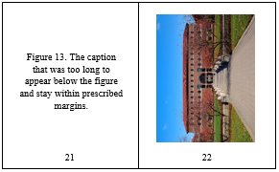
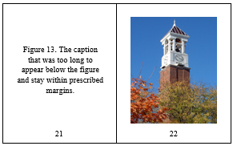

Figure 1.1. The figures above depict how to format captions for figures and tables that cannot accommodate an entire figure and its caption on one page. You can see that the caption is placed on the page BEFORE the figure/table and it is the only text on the page, vertically and horizontally aligned.
You may use landscaped pages for large tables or figures that normally will not fit within left and right margins. Note that page numbers will need to appear in the left margin with vertical text. A normal page number will show up in the upper right hand corner when adding pagination. You will need to unlink this page and the next page’s pagination to previous in order to keep the pagination in the correct place. Follow the steps on the next page to achieve a landscape page with proper pagination.

Table 1.1. How to format a landscape page. Since this table is the only content on this page and does not take up the entire page, it is centered on the page vertically to make the format more visually appealing.
Follow these steps to save the landscape page number in the left margin to your machine for easy landscape page number placement:
- Place a Next Page section break on the page BEFORE the intended landscape page and also on the last page of your intended landscape page.
- Place your cursor on the intended landscape page and using the Layout ribbon, choose Orientation > Landscape.
- Next, open the header on the new landscape page. Using the Design ribbon, choose ‘Link to previous’ in both the header and footer of the landscape page and the first portrait page after the landscape page.
- Open the header on this page.
- Select the text box that the page number is currently in.
- In the Ribbon above enter “Watermark” in the “Tell me what you want to do….” bar.
- Press the carrot next to ‘Watermark’.
- At the bottom of the pop out, choose ‘Save selection to Watermark Gallery’.
- In the new pop-out box, change the name to Purdue Landscape page number.
- Change gallery to ‘Page numbers (margins)’.
- Change category to ‘General’.
- OK
- Now, with the header open on the landscape page, go to Page number > Page margins > Purdue landscape page (or whatever name you saved it under).
- This will place the page number in the left margin and will automatically be updated if this page number changes.
- Now, with the page numbers on this page unlinked to the other pages around it, go to the footer and delete the page number.

Captions
All figure and table captions should appear single spaced throughout the text. If there is only one line of a caption, please center it under the figure or above the table. Captions may be centered or justified between margins. Be consistent throughout your entire document. See images below for examples of caption placement.
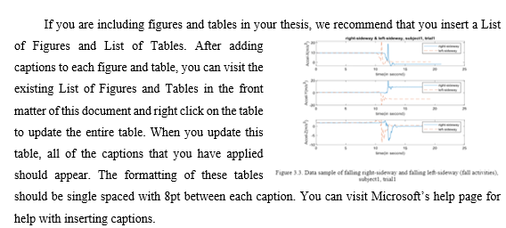
Figure 1.2. The figure depicted above is wrapped within text and has the caption immediately below the figure. This text-wrapping method is acceptable. Caption sizes may go as low as 10pt.
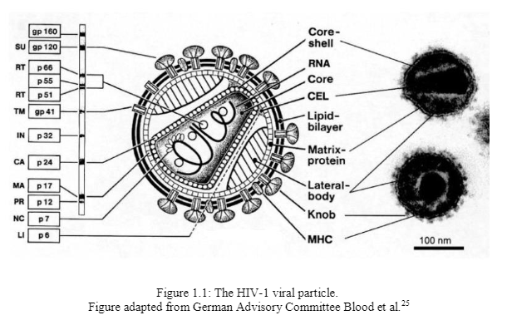
Figure 1.3. The figure depicted above fits between two paragraphs. Notice that the figure caption is single spaced and centered on the page. All figure captions should have 6pt space before and 24pt space after the captions.
Table 1.2. The table depicted below fits between two paragraphs. Table captions should be single spaced and centered on the page. All table captions should have 24pt space above and 6pt space after the captions. On this particular example, I have indented the caption 0.5” from both left and right margins to have a better appearance above the table.
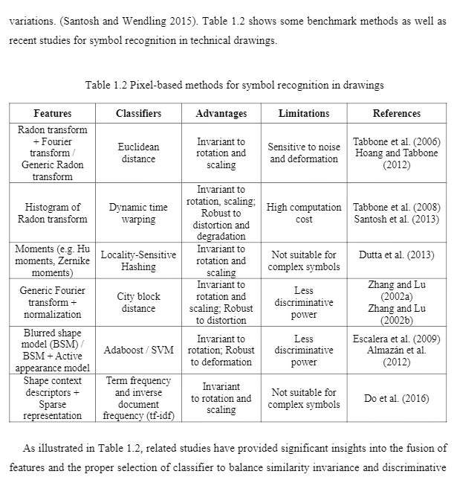
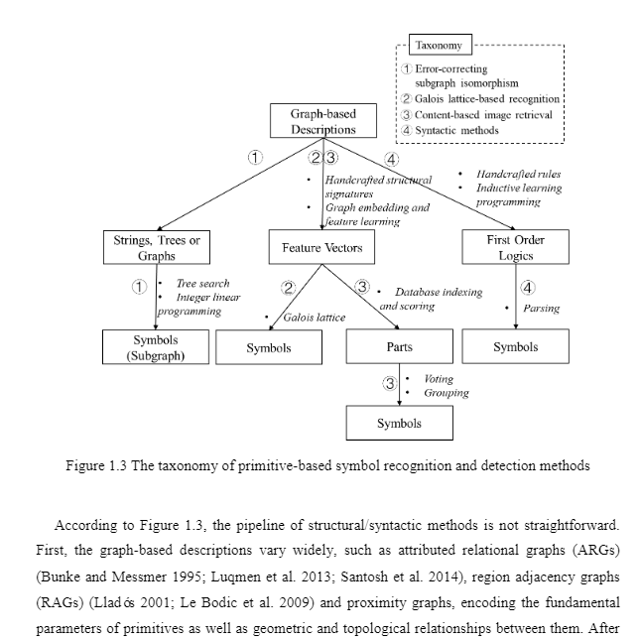
Figure 1.4. This figure represents depicts the amount of space that should appear between the figure caption and continuation of the text. The caption here is also indented from left and right margins to have a better appearance below the figure.

If you have a table or figure that split across multiple pages, the caption will need to remain on the first page of the table/figure and a Table or Figure continuation will need to be placed at the top of the next page. See examples of figure and table continuation below.
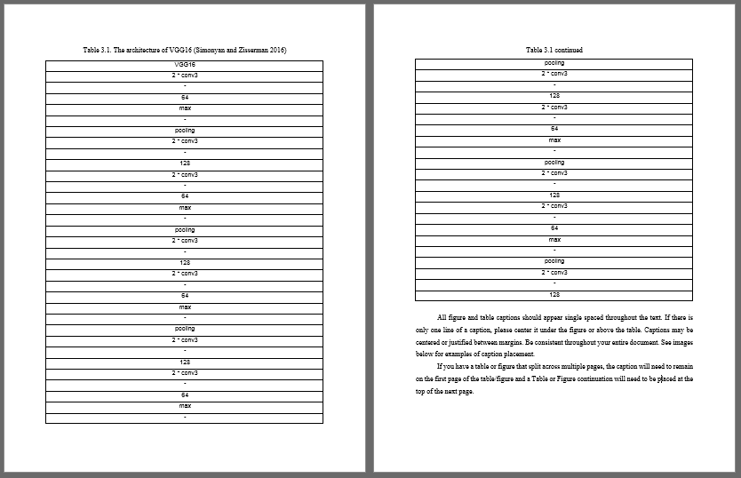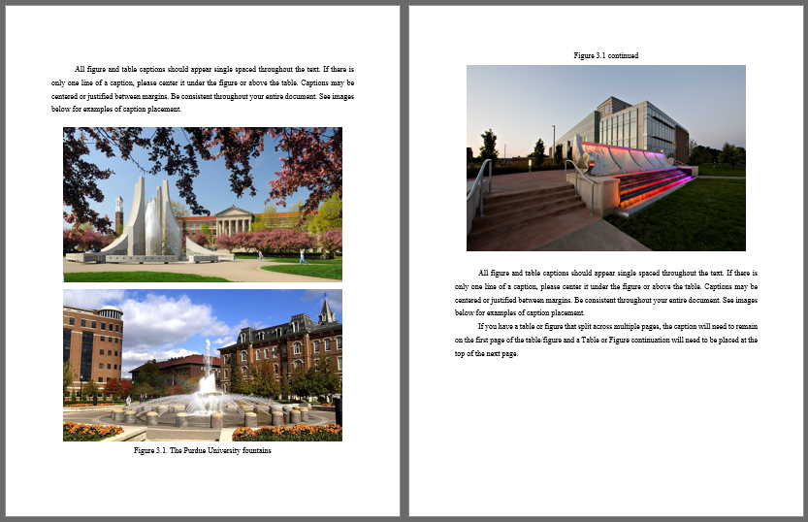
Adequate spacing between captions/text and captions/figure or table is required. Please follow the guide below to set adequate space around figure and table captions using the paragraph settings.
Table 1.3. This table shows what the spacing options should be between figures/tables and their captions. Add one extra space after tables to prevent text from bumping up against the table. If tables contain notes, you may leave the notes single space under the table and add one extra space below the note and before the continuation of main body text.
Table Captions (single spaced) |  | Figure Captions (single spaced) |  | Please add one extra space after tables and before figures to allow adequate space before and after main body text.
Before | 24 pt | Before | 6 pt
After | 6 pt | After | 24 pt
Note: this is an example of a note. Your notes may have multiple lines.

List of Figures and Tables
If you are including figures and tables in your thesis, we recommend that you insert a List of Figures and List of Tables. After adding captions to each figure and table, you can visit the existing List of Figures and Tables in the front matter of this document and right click on the table to update the entire table. When you update this table, all of the captions that you have applied should appear. The formatting of these tables should be single spaced with 8pt between each caption. You can visit Microsoft’s help page for help with inserting captions.

Page Numbers
Page numbers will go in the bottom middle of each portrait page. If you are using any landscape orientation pages, the page number will go in the left margin with vertical text (see page 11 for example). Page number font and font size needs to be the same as the main body text (12 point, Times New Roman)

Issues with Pagination
Occasionally, page numbers will overlap due to section breaks. To fix this issue, simply click on the page number and locate the Design ribbon at the top of the page. Click the drop down arrow on page number > Format page numbers > under the Page numbering section choose Continue from previous section.

Paragraph Settings
Paragraphs may be indented, as shown in this template, or they may remain un-indented. If you choose to keep your paragraphs un-indented, please be sure to add one extra space between paragraphs within a section. The paragraphs should be distinguishable from beginning to end. A combination of un-indented first paragraph of a section and subsequent paragraphs be indented may be used. Again, please be consistent in whichever style you choose. Paragraph settings have been set to be justified between left and right margins in this template. You may choose to use a ragged-right paragraph alignment.

Block quotes
Block quotes should be single spaced and indented one half inch from the left AND right margins. Please use the Block Quote style above to help format your block quotes.

Embedded Videos and 3D models
Videos and 3D models are permitted to be included in your thesis file, though these videos may make increase the file size of your document significantly. Exercise caution when sending large files as they may fail to send through email.
There are different methods to insert videos and 3D models depending on the version of Microsoft Word that you are using. If you need assistance in inserting these files into your thesis file, feel free to reach out to us for assistance.

Appendix
If including an appendix section please use the following format for the Appendix heading:
APPENDIX A. TITLE OF APPENDIX, APPENDIX B. TITLE OF APPENDIX, etc. Each appendix, like a new chapter, should begin on a new page.
There are no guidelines to follow for the Appendix sections; we just ask that you use a Major Heading style for the title and that the content fit between the left and right margins.

References
You may use a reference style that is most common in your discipline. You may choose to include a references section at the end of each chapter or you can choose to keep all references at the end of the entire document. References may appear in numerical or alphabetical order; if including at the end of each chapter, please be consistent across all chapters. If references are placed at the end of the chapters, they will need to continue after the text and have a level-one subheading applied to it.
Example:
1.7 References

Format your references to be either single-spaced with one extra space after each entry, or maximum 1.5 line spacing indented.

Cross-reference
You are permitted to use cross-references within your thesis file. This especially helps with linking text to tables, figures, and other graphs. Use the instructions found in Microsoft’s Create a cross-reference page for assistance in creating cross references.

Document Accessibility Statement
According to Purdue University Policy, Electronic Information, Communication and Technology Accessibility (S-5): As a public university and federal contractor, Purdue University is required to adhere to Sections 504 and 508 of the Rehabilitation Act of 1973 and Title II of the Americans with Disabilities Act. This standard specifies the means by which the University ensures compliance with these laws.
Use Microsoft’s accessibility guide to help create an accessible document. When you initiate Form 9, you will need to certify that in the preparation of this thesis/dissertation, you have to the best of your ability, created an accessible document that is in compliance with sections 504 and 508 of the Rehabilitation Act of 1973 and Title II of the Americans with Disabilities Act.

THIS BEGINS A NEW CHAPTER
Begin a new chapter here. Each chapter must begin on a new page. If you are pasting in previously published articles, you will need to reformat the articles to match the guidelines that are set in this template. You will also want to use the heading styles above even though you may have previously applied styles in the original document. The styles above will ensure you meet the Graduate School requirements.

APPENDIX A. SURVEYS
OPTIONAL SECTION

The appendix titles have a ‘Major Heading’ style applied. These will allow for an un-indented appearance in the table of contents. Tables and figures that appear within this section DO NOT need to appear in the list of figures or tables. However, you may label your appendix figures/tables as Figure/Table A.1, Figure/Table A.2, etc. If you have multiple appendices please change the label letter with each new appendix (example: Figure A.1, Figure B.1, Figure C.1, etc.).
The Graduate School is fairly flexible with the appendix format. We just ask that text, figures, and tables fit within all margin requirements.

APPENDIX B. THIS IS A NEW APPENDIX
Each appendix title should have a letter and title associated with it. If you only have one appendix, the heading should only read “APPENDIX” with no other title. Although, you may add a title in a smaller font 3 single spaces below the APPENDIX title.

REFERENCES
References may either be a separate section (like shown in this template) or they may be listed after each chapter. If references are placed at the end of the chapters, they will need to continue after the text and have a level-one subheading applied to it.
Example:
1.7 References

References and Appendix placement may be changed to fit the needs of the author.

Examples:

(APA style in Alphabetical order)
Applewood, John (2015, December 17). How to Format a Purdue Thesis. Retrieved from http://www.purdue.edu/gradschool/research/thesis/index.html
Brownstone, Daniel (2015, January 24). Sample Thesis Pages. Retrieved from http://www.purdue.edu/gradschool/research/thesis/index.html

-OR-

(APA style in Endnote referenced order)
[1] Brownstone, Daniel (2015, January 24). Sample Thesis Pages. Retrieved from http://www.purdue.edu/gradschool/research/thesis/index.html
[2] Applewood, John (2015, December 17). How to Format a Purdue Thesis. Retrieved from http://www.purdue.edu/gradschool/research/thesis/index.html

Follow your department’s style for your References section and be consistent throughout the entire document.

VITA
REQUIRED FOR ECE STUDENTS ONLY, OTHERS OPTIONAL

Do not include any private data like your home address, email address, or phone number.

If you are unsure about what to include in your vita, consult with your department and/or major professor. The vita can be written as a narrative or in curriculum vita (CV) form. Please keep vita format identical to the format used in thesis (margins, spacing, and text font).

PUBLICATIONS
OPTIONAL SECTION

This is where you can place a list of publication or alternately, you can include a PDF of a published article. This article may either be in color or black and white. If you have questions or need any guidance inserting a PDF into your document, contact our office.
All pages of publications need page numbers sequential to the number in the rest of your thesis. You may need to block out original page numbers to prevent confusion. You may use the landscape text box and rotate it to fit in the upper right hand corner of the page. You will need to ensure the page number is horizontal when using the text box.

If you have only one publication, list the title as PUBLICATION.

Alternatively, you may link your publication to your submission profile on HammerRR by adding a link to the References section.

