How to Order an IU Transcript as a former IPFW student
https://transcript.iu.edu/

Click “Ready to Order?”
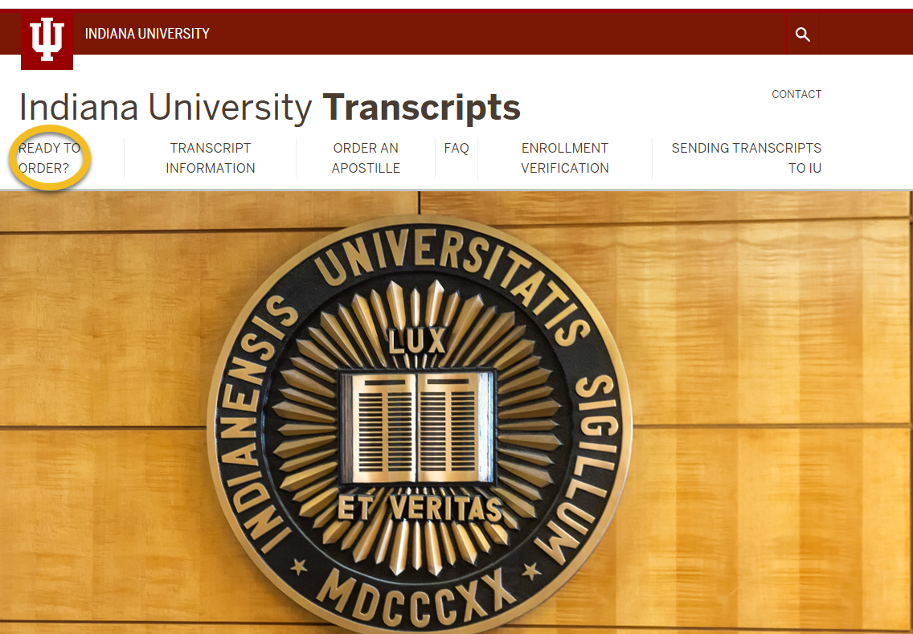
Carefully read the information and then select “Former Students” for the ordering method below that best represents you:

Current Students

Former Students

High School Dual Credit/ACP Students

Sending Transcript with Attachment (CAS)

Third Party Orders On Behalf of the Student

Transcript Pricing and Delivery Options

Unofficial Transcript

Please use the Signature Request method if:
- Dual Credit or Advanced College Prep (ACP) High School Students
- Former IPFW or current IU Fort Wayne students
- Attach form(s) to send with a paper transcript
- Former students unable to login to a One.iu.edu account
- Records contain coursework from earlier than 1965
- Unable to use the fully automated system
OPTION 2 - Manually Processed (Signature Request) System
The Signature Request system is a two step system placed online and manually processed to order electronic and paper transcripts. Please allow 1-3 business days for processing. Your order cannot be processed until payment and your handwritten signature has been received.
If you have forms to send attached to your transcript, please order a paper transcript and remember to include the forms when submitting your signed Step 2 Authorization form. For more information about sending IU transcripts with attachments, please select the "Sending Transcript with Attachment" ordering method or review our FAQ here.
Order Online (Signature Request)
As a former IPFW student, you will want to scroll down and click “Order Online (Signature Request)”

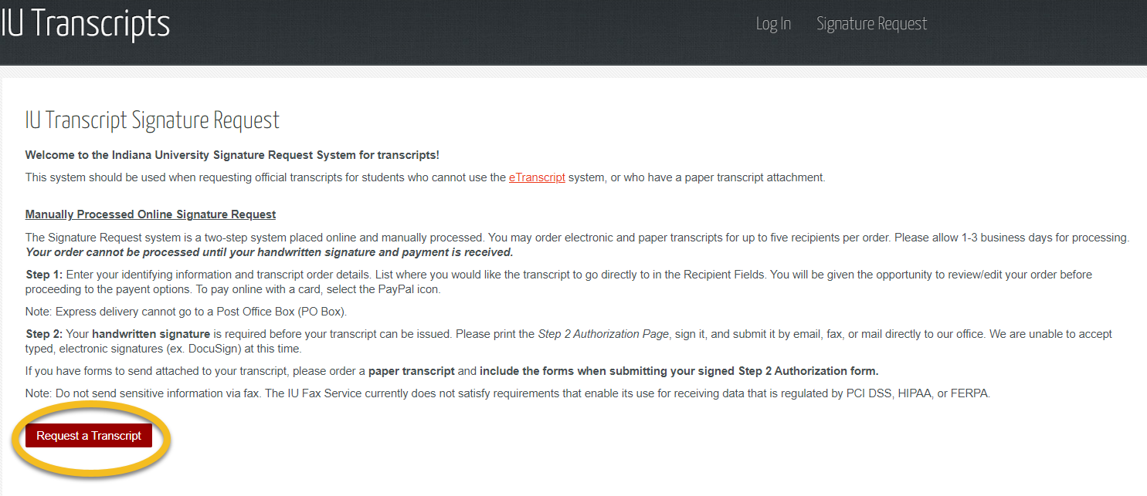

Complete the instructions and order your transcript.
If you have any questions, please contact IU Bloomington at 812-855-4500.

